**NAME:_______________________________**

**Particle in Infinite Square Well Worksheet**

**Physics 205**

**Prof. Singal**

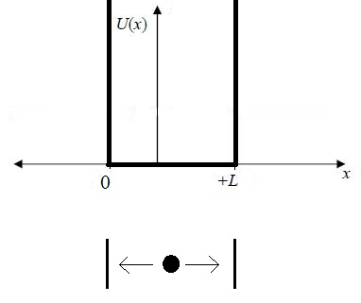

1) Recall that the probability of finding our particle between x = a and x = b is given by $P_{ab}=\int_{a}^{b}{{\left|ψ(x)\right|}^{2}dx}$. $ψ(x)$ is a function for all x, from $x=∞$ to $x=-∞$. If our one-dimensional box (or tube really) goes from x=0 to x=L:

a) What is $ψ(x)$ for $-∞<x<0$?

b) What is $ψ\left(x\right)$ for $x>L$?

c) What should $\int_{-∞}^{∞}{{ψ(x)}^{2} dx}$ be?

d) In order for $ψ\left(x\right)$ to be continuous, whatever the functional form of it is inside the box, what should its value be at x=0 and x=L?

Within the range 0<x <L , you can find $ψ(x)$ using the time independent Schrödinger equation:

$$-\frac{ℏ^{2}}{2m}\frac{d^{2}ψ}{dx^{2}}+U\left(x\right)ψ\left(x\right)=Eψ\left(x\right)$$

and inside the box .

2. What are some functions that satisfy the Schrödinger equation *inside* the 1-D box? (Here, the

Schrödinger equation says basically that the second derivative of a function is a bunch of constants times the negative of that same function.)

To give yourself a preview of what $ψ(x)$ looks like for different values of energy E, open the

following page in Internet Explorer:

<http://webphysics.davidson.edu/physletprob/ch10_modern/>default.html

Click on “Infinite Well” on the left hand side and let the Java applet run. This simulation shows a 1-dimensional box running from x =-1.00 to x=+1.00 (instead of from x=0 to x=L). The potential energy is shown as a red line at U=0, with the “infinite” vertical walls just off screen. Initially, your particle has been given an energy of E=2.467 (in some units), which leads to a function inside the box $ψ_{in}(x)$ shown in blue.

3) Draw sketches of the inside $ψ_{in}(x)$ below for E=2.467 , E=6 , E=10 , and E=14 or close to them. You can put a value of E in and press enter. (Notice that the y-axis of the graph of the inside $ψ_{in}(x)$ shifts up as you increase the energy, as you can verify by trying E=300. You can basically ignore this upward shift).

4) For the graphs that you made above, for the inside portion $ψ_{in}(x)$, which values of E come closest to producing a graph of $ψ(x)$ that is continuous everywhere, including at x =+1.00? (Again, ignore that different values of E shift the graph up and down and instead imaging y=0 being in the middle of the wave, and remember that in this simulation the box length is from

x =-1.00 to x=+1.00 instead of from x=0 to x=L.)

5) Continue typing values for E into the box, and find two more values of energy that produce continuous functions for $ψ(x)$. At some point, when you tire of this game, you can play with typing in *n*=2 or *n*=3, and clicking on “find.” What are the lowest four values of E that produce continuous functions for ?

6) Draw quick sketches of $ψ(x)$ and ${ψ(x)}^{2}$ over the range $-∞<x<∞$ for *n*=1, *n*=2, and *n*=3.

7) The computer simulation showed you that to produce a continuous function for $ψ(x)$, only some values of E are allowed. Now go back to the equations that you found in question 2.

a) If you wrote more than one function in question 2, only one of them will work now considering what has to happen at x=0. Which one?

b) Given that function, what must k be such that $ψ_{in}(x)$ is zero at x=0 and x=L?

8) Now use the Shrodinger equation and take the derivatives to write an expression for the allowed values of E in terms of *h*, *m*, L, and *n*.

We have derived that the energy is *quantized*! In classical mechanics we could give a particle any energy but in this case we see that if we are using quantum physics only discrete values of energy are possible.